
G6PD Test Kit
For professional in vitro diagnostic use only
Model | HG6PD-402 | Specimens: | Whole blood
Version | B | Effective Date: | 2025.02

INTENDED USE
This G6PD Test Kit is used for qualitative detection of normal or deficient G6PD enzyme activity in whole blood samples. It is intended for in vitro clinical auxiliary diagnosis of glucose-6-phosphate dehydrogenase deficiency.

SUMMARY
Gluclose-6-phosphate dehydrogenase(G6PD) is a hereditary disease caused by a defect in the G6PD enzyme of red blood cell membranes. This defect leads to a decrease in the production of reduced nicotinamide adenine dinucleotide phosphate(NADPH), which is essential for maintaining the stability of red blood cell membranes and protecting against oxidative damage. The deficiency can result in red blood cell destruction and hemolysis. Symptoms often occur after consuming fava beans, a condition known as “favism”. G6PD deficiency is an X-linked genetic disorder, with male carriers usually exhibiting a dominant phenotype. Female carriers with homozygous or compound heterozygous mutations can also manifest as dominant phenotype. However, most female carriers with a single heterozygous mutation are asymptomatic carriers, and only a small percentage may develop G6PD deficiency. Patients with G6PD deficiency are unable to metabolize glucose properly, as G6PD is the rate-limiting enzyme in the pentose phosphate pathway. Exposure to oxidative substances such as fava beans, aspirin and sulfonamide drugs can trigger acute hemolytic reactions, leading to symptoms such as jaundice, mental impairment, and , in severe cases, rapid breathing heart failure, and shock, which can be life-threatening. The measurement of G6PD enzyme activity is of great clinical significance.

PRINCIPLE
The G6PD Test Kit utilizes the glucose-6-phosphate substrate colorimetric method. In this method, glucose-6-phosphate in the sample is oxidized by the G6PD enzyme in the presence of NADP, resulting in the production of 6-phosphogluconic acid lactone and NADPH. The NADPH then reacts with the light yellow nitrotetrazolium blue chloride (NBT), reducing it to insoluble blue-purple crystalline formazan. In the presence of normal G6PD enzyme activity, insoluble blue-purple crystals are formed. The test kit includes a filtration membrane that removes hemoglobin from the sample, allowing the purple crystals to bind to the membrane and form a visible blue-purple circular spot. However, when G6PD enzyme activity is defect, the blue-purple circular spot cannot be formed, indicating a deficiency in G6PD enzyme.
STORAGE AND STABILITY
Storage conditions: sealed dry storage, 2-30℃ room temperature storage.
Validity period: 24months.
The card and tube should be used within 20 minutes after opening the aluminum foil bag, and the humidity requires no more than 80%.
It is crucial to use the kit within the specified validity period.
Production date and expiration date : see outer box.

MATERIALS
Components | 1 test/Kit | 5 tests/Kit | 10 tests/Kit | 20 tests/Kit
Card (piece) | 1 | 5 | 10 | 20
Buffer (bottle) | 1 | 1 | 1 | 1
Tube (piece) | 1 | 5 | 10 | 20
IFU | 1 | 1 | 1 | 1

HOW TO USE
Please read the instructions carefully before testing and restore all reagents to room temperature. The test should be carried out at room temperature. Please prepare a timer and follow the operation steps:
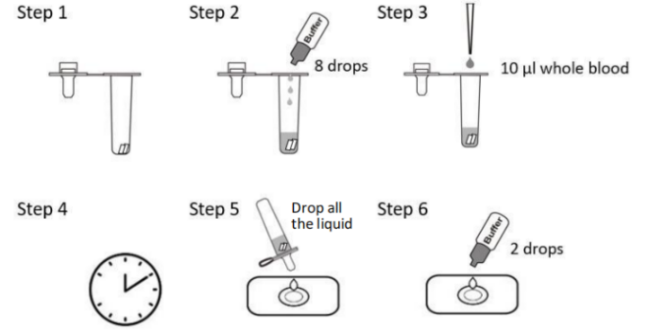

- Reagent preparation:
Open an aluminum foil bag in the kit and take out a card and a tube.
Note: there are 2 reagent pads inside the tube.
- Adding buffer:
Add 8 drops (approximately 300ul) of buffer into the tube.
Note: The reagent pads are insoluble.
- Adding sample:
Mix the blood sample thoroughly, add 10 ul blood sample in to the tube, mix well and start timing.
Note: Make sure the 2 pads are soaked in the mixture.
- Waiting:
Allow the mixture in the tube to incubate for 10 minutes.
- Dropping reacted mixture:
Take out one Card, drop all the reacted mixture to the hole of the card, generally it takes about 1 minute for the liquid to completely permeate.
- After the liquid has permeated, adding further 2 drops of buffer in the hole can stable the colored spot.
- Read result:
The result should be read within 10 minutes.
INTERPRETATION OF RESULTS
Normal | Deficient
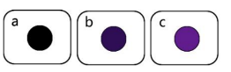 | 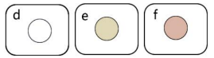
The spot color is black, purple – blue or purple (a,b,c). | The spot color is white, yellow or pink (d,e,f).
Intermediate Result: for intermediate color, please refer to the above picture to interpret.

PRECAUTIONS
- This reagent is for in vitro diagnostic use only. Please read the instructions carefully before testing.
- This reagent is for one-time use only. Do not reuse.
- This reagent must be used within the specified shelf life.
- Strictly follow the instructions and do not mix different batches of test cards and sample extraction solutions.
- Operational errors or insufficient sample volume may lead to deviations in test results.
- Do not use the product if the plastic packaging of the test card is damaged.
- Do not inhale the sample extraction solution.
- The aluminum foil bag contains a desiccant and should not be ingested.
- Store strictly according to the requirements in the instructions.
- The reagent pad in the handling tube contains a small amount of powder that should not be removed. The splashed powder may cause irritation to the skin and eyes. If the solution comes into contact with the skin or eyes, rinse with plenty of water. Seek medical attention if skin irritation or discomfort occurs.
- Strictly control the reaction time during operation, as excessively long reaction time may result in false negatives.
- This test card is one of the auxiliary diagnostic methods and the test results are for reference only. They should not be the sole basis for clinical diagnosis and treatment. Positive results need to be further confirmed by other methods. This reagent is for qualitative testing and cannot be used for quantitative analysis.

SPECIMEN COLLECTION AND PREPARATIONS
Whole blood collection: use anticoagulant tube (suggest EDTA anticoagulation) to collect blood. Add the collected blood to the anticoagulant tube and shake well for later use. Whole blood can be collected by whole blood sampler at fingertips and earlobes. After collection, tests should be carried out as soon as possible to avoid the use of hemolysis samples. It is recommended to test the sample within 24 hours after collections. If immediate testing is not possible, the samples can be stored at a temperature between 2-8℃ for a maximum of 7 days.
Do not freeze samples prior to testing. Do not centrifuge samples before testing.

LIMITATIONS
- Differentiating Enzyme Activity Levels: The kit is designed to distinguish between normal levels of G6PD enzyme activity and a lack of enzyme activity. However, it cannot assess the degree of deficiency or provide quantitative measurements of G6PD enzyme levels in samples. It is primarily used for qualitative testing.
- Impact of Hematocrit Levels: Abnormally low or high hematocrit levels can affect the performance of the test. G6PD is primarily found in red blood cells, and hematocrit refers to the volume of red blood cells in a given volume of blood. Low Hematocrit: A low erythrocyte specific volume indicates a low number of red blood cells in a specific volume of blood. This can increase the risk of false defect results in normal samples because there are fewer red blood cells, resulting in insufficient total G6PD enzymes. High Hematocrit: Conversely, a high erythrocyte volume indicates a large number of red blood cells compared to a normal sample. In this case, a high hematocrit level increases the risk of a false normal outcome. It is important to consider these limitations and take them into account when interpreting the results of the G6PD Test Kit

PERFORMANCE CHARACTERISTICS
[Limit of Detection (LoD)]
Based on the enzyme activity determined by the licensed quantitative detection kit, the detection of this kit is 30 U/dl.

[Interfering Substances]
The following potentially interfering substances were added into normal/ deficient Gluocose-6-phosphatedehydrogenase whole blood sample.
No substances showed any interference with the test.
Substances | Conc.
Bilirubin | 330 umol/L
Total cholesterol | 20 mM
Glucose | 15 mM
Triglycerides | 8.5 mM
Lactate | 17 mM
Lactate dehydrogenase | 500 U/L

[Cross-reactivity]
The G6PD Test Kit has been tested by variable substances.
The results showed no cross-reactivity.

Substances
Vitamin C
Fe 2+
H2O2
Alcohol

[Precision]
- Intra-assay
Within-run precision has been determined by using 3 replicates of 3 specimens. The values were correctly identified >99% of the time.
- Inter-assay
Between-run precision has been determined by 15 independent assays on the same three different specimens. Three different lots of the G6PD Test Kit have been tested using three different specimens. The coincidence rates were all 100%.
[Clinical Performance]
Based on the clinical trials comparing the G6PD Test Kit with the CareStart G6PD Test Kit, the following test results were obtained using 214 heparinized and EDTA-anticoagulated whole blood samples:
 | CareStart G6PD TEST kit
Hysen G6PD  Test Kit | Normal | Deficit | Total results
Normal | 150 | 3 | 153
Deficit | 2 | 59 | 61
Total Results | 152 | 62 | 214

Relativity Sensitivity: 98.68% (95.33 to 99.84%) Accuracy: 97.66% (94.63% to 99.24%)
Relativity Specificity: 95.16% (86.5% to 98.99%) 95% Confidence Intervals

Reference
A simple Method for Detection of Erythrocyte Glucose-6-Phosphate Dehydrogenase Deficiency (G-6-PD Spot Test)V. Fairbanks, E Beutler.

